1.Go to the S3 Dashboard

2.Click on Create Bucket Button

3.Enter the Bucket name and select the region that you want (ndnvp-demo-tyif-2022)

4.Now bucket is created you can see in S3 Dashboard

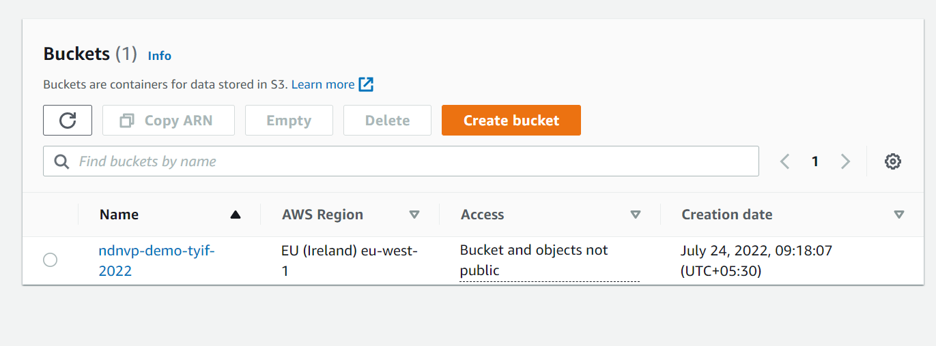

5.Click on Upload button and add sample html and images file.

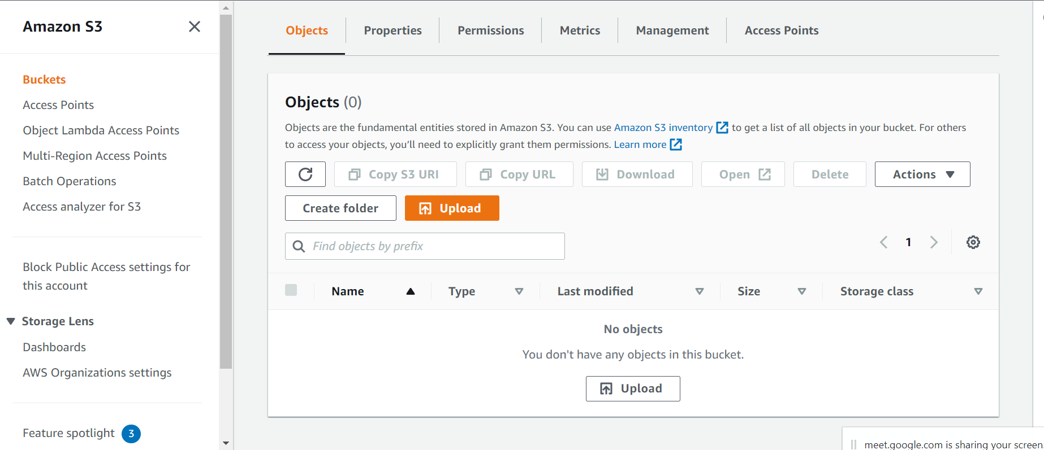

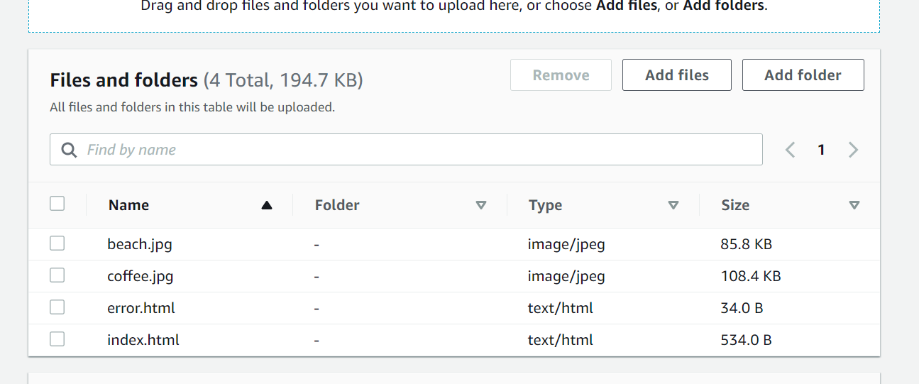

6. Click on Properties and select the static website hosting and click on edit button.

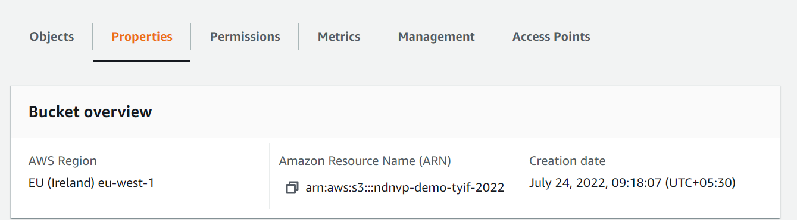

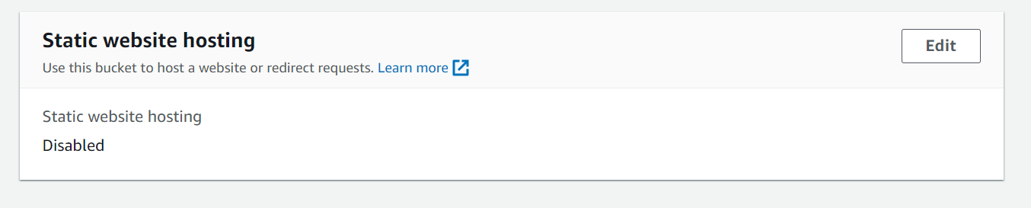

7. Please configure as below and click on save button

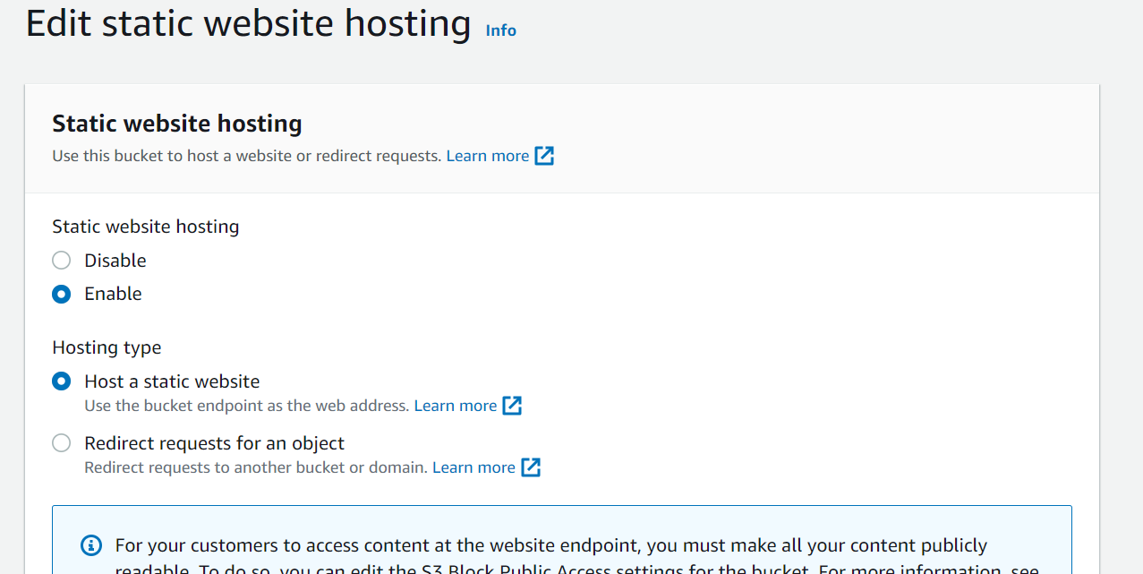

8. 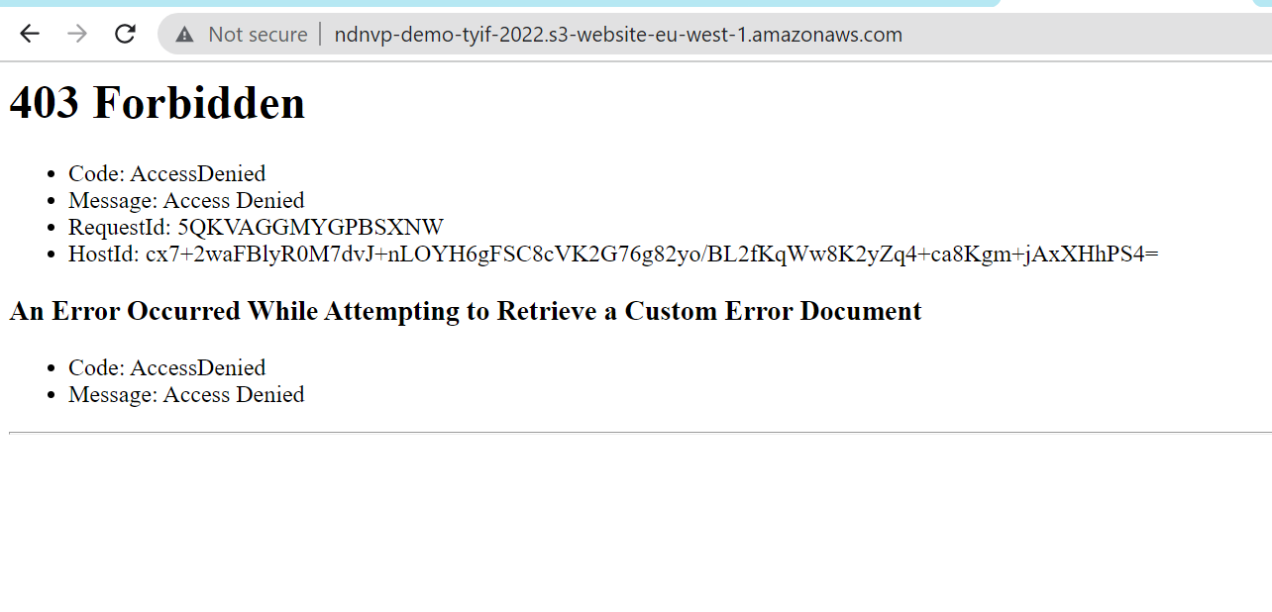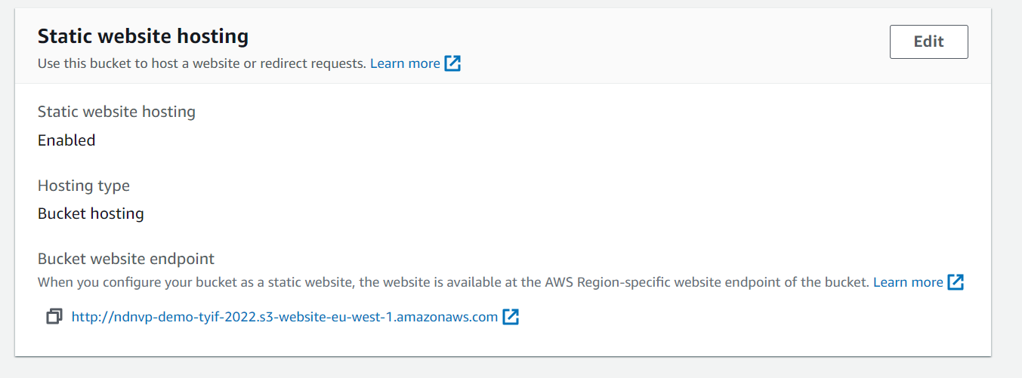  
8.Copy the Bucket Website URL and enter into another tab and you will get 403 forbidden issue as above images.

9.To fix this issue we have to setup permissions.

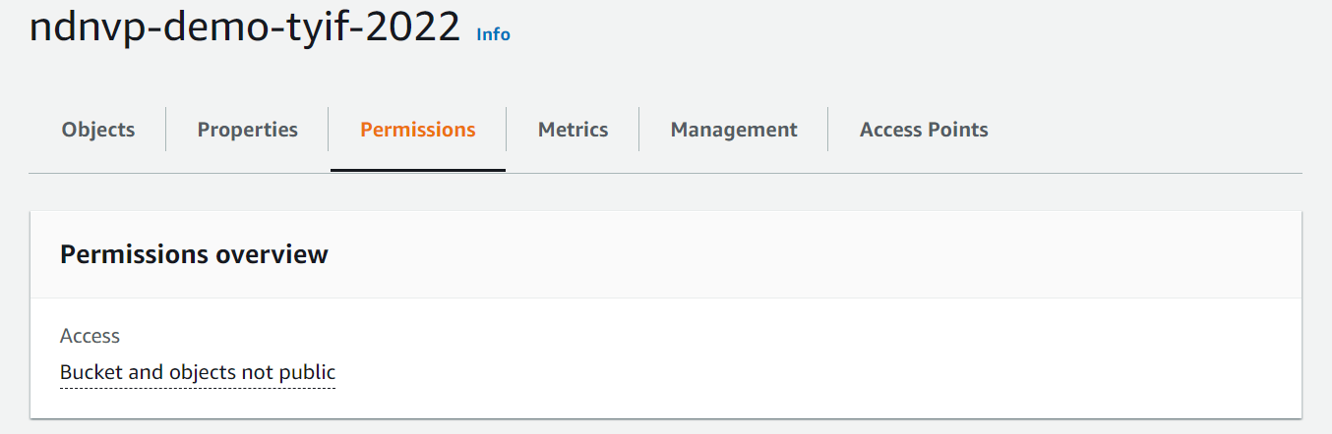

10. Uncheck the Block all public access check box. And click on save changes button.

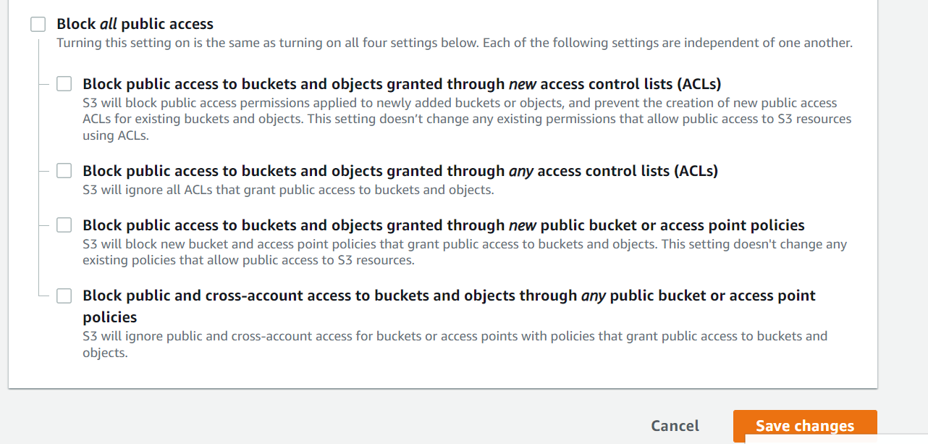

11. Enter the confirm text in text box field and click on button as well.

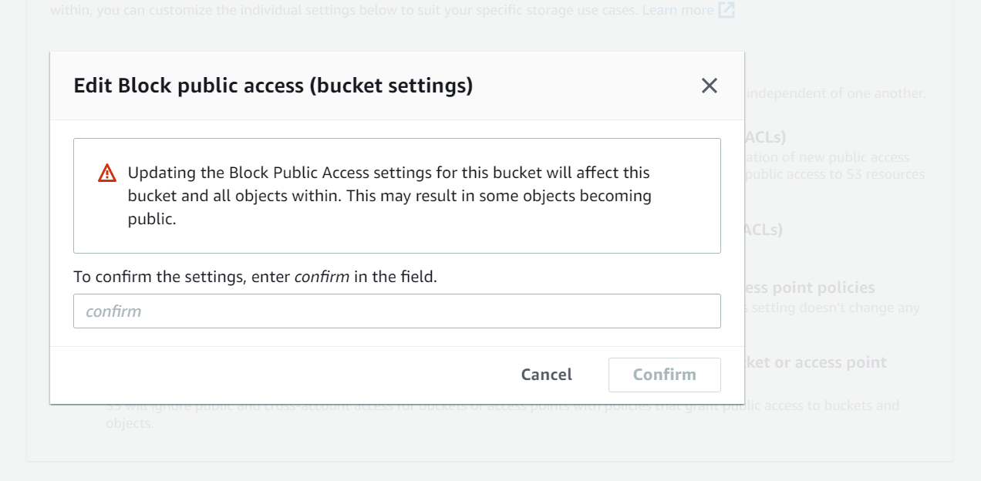

12.Click on Edit Bucket policy option and enter the below polices.

{

"Version": "2012-10-17",

"Id": "Policy1658633007055",

"Statement": [

{

"Sid": "Stmt1658633003330",

"Effect": "Allow",

"Principal": "\*",

"Action": "s3:GetObject",

"Resource": "arn:aws:s3:::ndnvp-demo-tyif-2022/\*"

}

]

}

Under this resources give your resources name and add /\* at the end as shown above.

Copy and past this policy into text and click on save button.

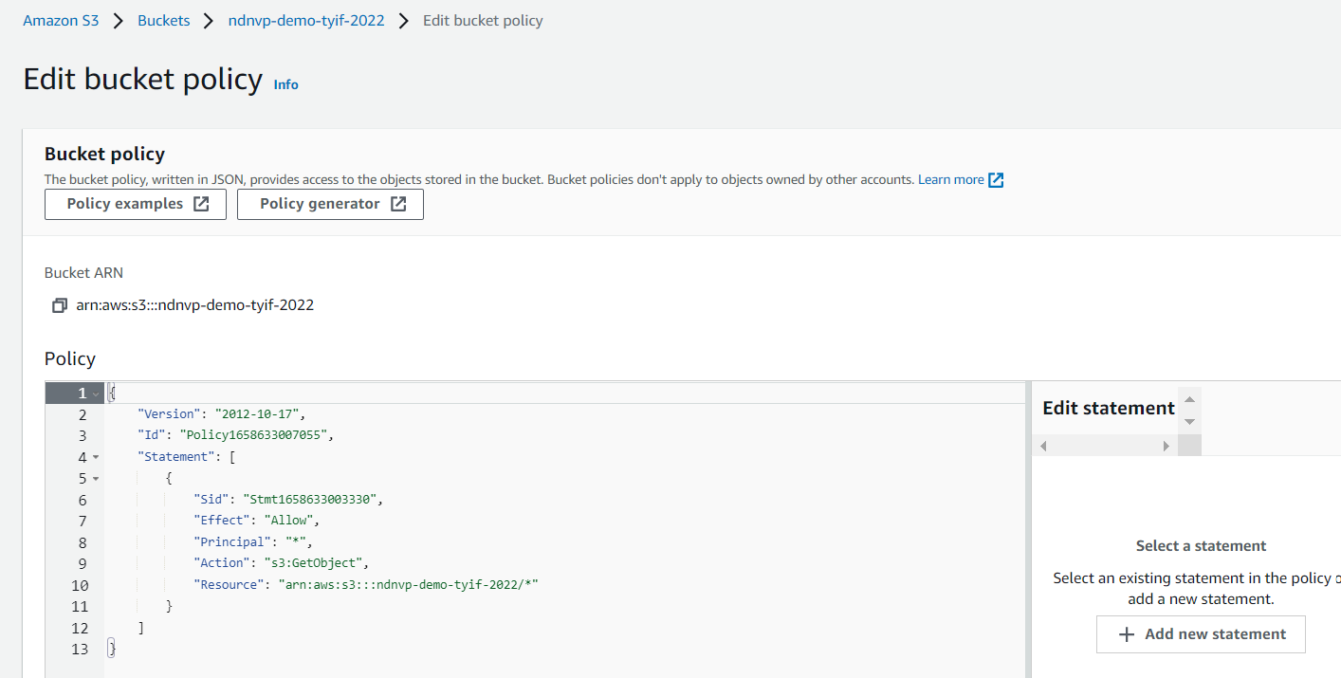

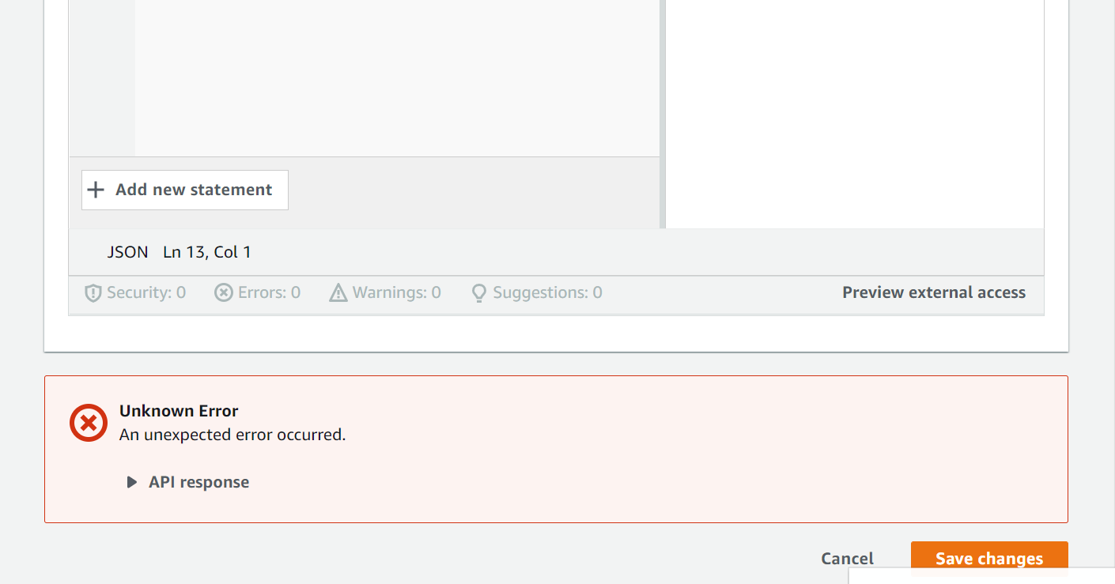

13.Now your bucket is public and you are able to access it.

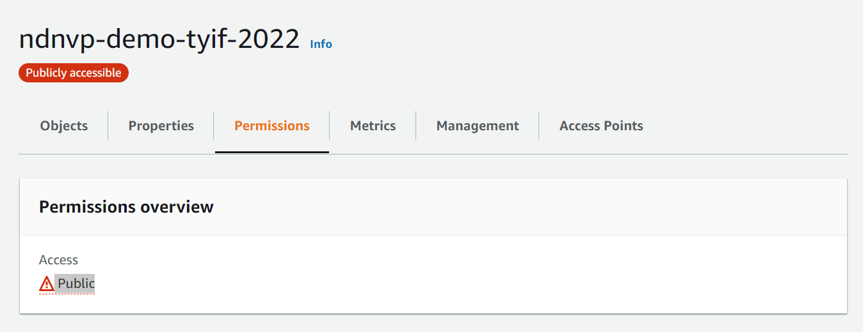

Now your website is up and working fine.

http://ndnvp-demo-tyif-2022.s3-website-eu-west-1.amazonaws.com

<http://ndnvp-demo-tyif-2022.s3-website-eu-west-1.amazonaws.com/error.html>

   